## Request refusal

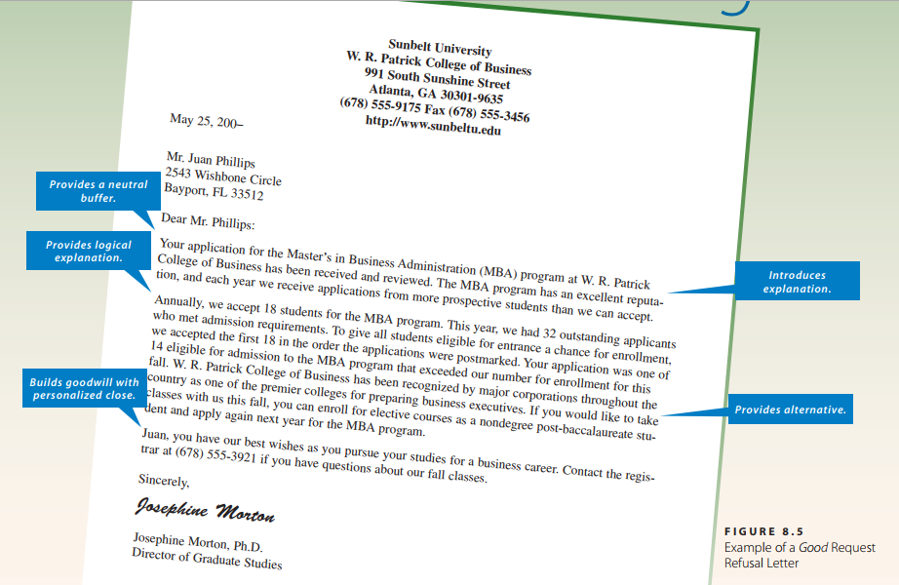

Sunbelt University  
W. R. Patrick College of Business  
991 South Sunshine Street  
Atlanta, GA 30301-9635  
(678) 555-9175 Fax (678) 555-3456

<http://www.sunbeltu.edu>

May 25, 200–

Mr. Juan Phillips

2543 Wishbone Circle  
Bayport, FL 33512

Dear Mr. Phillips:  
Your application for the Master’s in Business Administration (MBA) program at W. R. Patrick  
College of Business has been received and reviewed. The MBA program has an excellent reputation, and each year we receive applications from more prospective students than we can accept.  
Annually, we accept 18 students for the MBA program. This year, we had 32 outstanding applicants who met admission requirements. To give all students eligible for entrance a chance for enrollment, we accepted the first 18 in the order the applications were postmarked. Your application was one of 14 eligible for admission to the MBA program that exceeded our number for enrollment for this fall. W. R. Patrick College of Business has been recognized by major corporations throughout the country as one of the premier colleges for preparing business executives. If you would like to take classes with us this fall, you can enroll for elective courses as a nondegree post-baccalaureate student and apply again next year for the MBA program.

Juan, you have our best wishes as you pursue your studies for a business career. Contact the registrar at (678) 555-3921 if you have questions about our fall classes.

Sincerely,  
*Josephine Morton*Josephine Morton, Ph.D.  
Director of Graduate Studies

## Adjustment refusal

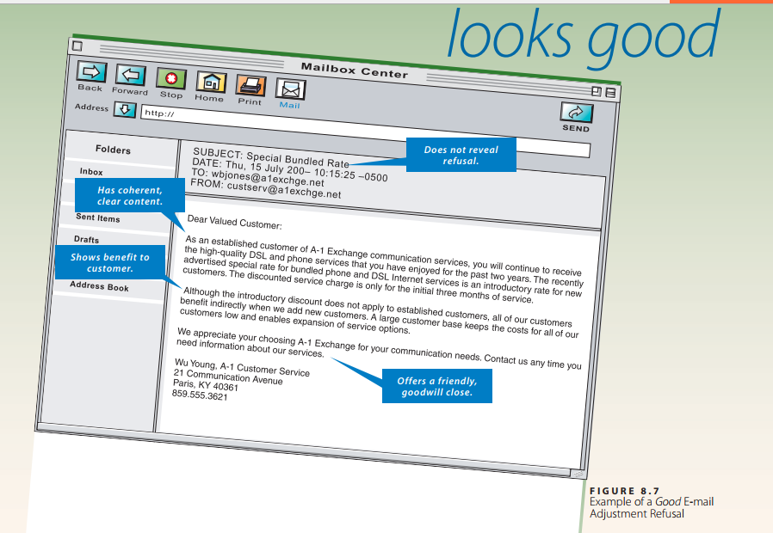

Subject: Special Bundled Rate

Date: Thu, 15 July 200- 10:15:25

To: [wbjones@g1exchage.net](mailto:wbjones@g1exchage.net)

From: cusservice@g1exchage.net

Dear Valued Customer,

As an establishment customer of A-1 Exchange communication services, you will continue to receive the high-quality DSL and phone services that you have enjoyed for the past two years. The recently advertised special rate for bundled phone and DSL Internet services is an introductory rate for new customers. The discounted service charge is only for the initial three months of service.

Although the introductory discount does not apply to established customers, all of our customers benefit indirectly when we add new customers. A large customer base keeps the costs for all of our customers low and enables expansion of service options.

We appreciate your choosing A-1 Exchange for your communication needs. Contact us any time you need information about our services.

Wu Chung, A-1 Customer Service

21 Communication Avenue

Paris, KY 40361

859.555.3621

## Credit refusal

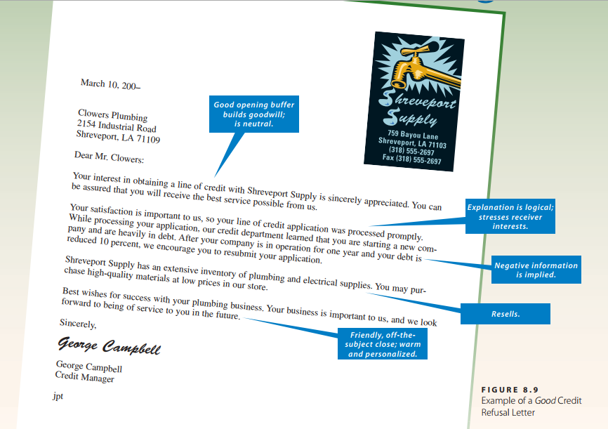

Shreveport Supply

759 Bayou Lane

Shreveport, LA 71103

(318) 555-2697

Fax (318) 555-2697

March 10, 200–

Clowers Plumbing  
2154 Industrial Road  
Shreveport, LA 71109

Dear Mr. Clowers:  
Your interest in obtaining a line of credit with Shreveport Supply is sincerely appreciated. You can be assured that you will receive the best service possible from us.

Your satisfaction is important to us, so your line of credit application was processed promptly.  
While processing your application, our credit department learned that you are starting a new company and are heavily in debt. After your company is in operation for one year and your debt is reduced 10 percent, we encourage you to resubmit your application.

Shreveport Supply has an extensive inventory of plumbing and electrical supplies. You may purchase high-quality materials at low prices in our store.

Best wishes for success with your plumbing business. Your business is important to us, and we look forward to being of service to you in the future.

Sincerely,  
*George Campbell*George Campbell  
Credit Manager  
jpt

## Unsolicited negative message

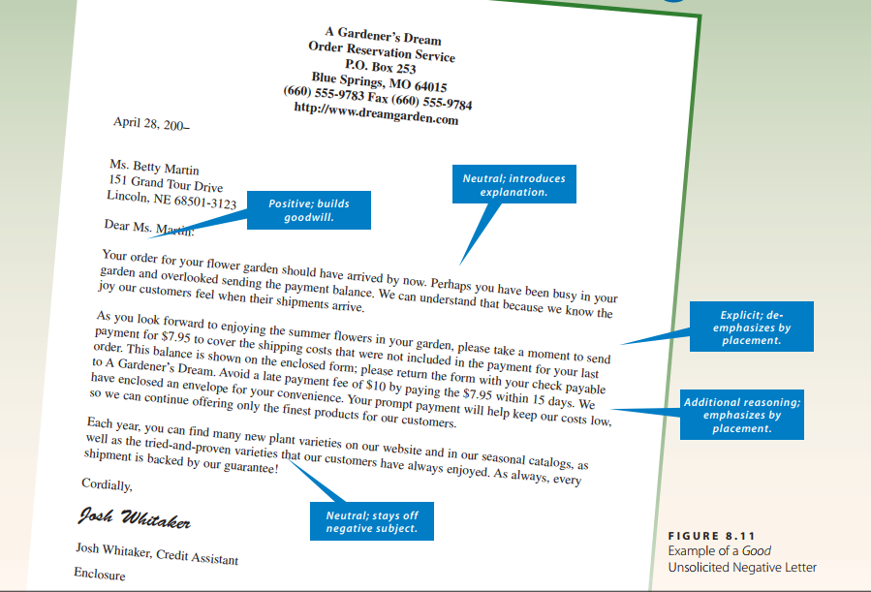

A Gardener’s Dream  
Order Reservation Service  
P.O. Box 253  
Blue Springs, MO 64015  
(660) 555-9783 Fax (660) 555-9784

<http://www.dreamgarden.com>

April 28, 200–

Ms. Betty Martin  
151 Grand Tour Drive

Lincoln, NE 68501-3123

Dear Ms. Martin:

Your order for your flower garden should have arrived by now. Perhaps you have been busy in your garden and overlooked sending the payment balance. We can understand that because we know the joy our customers feel when their shipments arrive.

As you look forward to enjoying the summer flowers in your garden, please take a moment to send payment for $7.95 to cover the shipping costs that were not included in the payment for your last  
order. This balance is shown on the enclosed form; please return the form with your check payable to A Gardener’s Dream. Avoid a late payment fee of $10 by paying the $7.95 within 15 days. We have enclosed an envelope for your convenience. Your prompt payment will help keep our costs low, so we can continue offering only the finest products for our customers.

Each year, you can find many new plant varieties on our website and in our seasonal catalogs, as  
well as the tried-and-proven varieties that our customers have always enjoyed. As always, every  
shipment is backed by our guarantee!

Cordially,  
*Josh Whitaker*

Josh Whitaker, Credit Assistant  
Enclosure